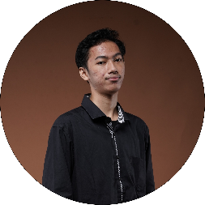

**ZAM ZAM SAVANA**

**Student of Highschool 1 Yogyakarta**

Yogyakarta, Indonesia | Phone: +62 812 2834 6375 | Email: [zamzamsavana@gmail.com](mailto:zamzamsavana@gmail.com)

**SUMMARY**

A school student who is in grade 12. Passionate about graphic design with approximately 1 year of experience using software. Coupled with the experience of the organization that I follow which aims to increase knowledge in establishing relationships and dealing with other people.

**EXPERIENCE**

**VICE PRESIDENT II PH OBTB 2021/2022**

Organize the organization and become a harmonic between students and the school.

* Practice public speaking & problem solve
* Team work and socialize
* Great communication

**MEMBER OF COMPANION DIVISION BPLS 2021**

Accompanying new students by introducing the school so that new students can adapt to school.

* Make relation with juniors
* Practice how to be patience

**VICE PRESIDENT II TELADAN MAKARYA MIGUNANI 2021**

Develop my potential to contribute to a program for the first time.

* Manage priorities well
* Events to add relationships

**EDUCATION**

* **HIGHSCHOOL 1 YOGYAKARTA (2020-NOW)**
* **JUNIOR HIGHSCHOOL 5 YOGYAKARTA (2018-2020)**

**SKILL**

* Operating Corel Draw
* Design graphics
* Planner